ReaLogView DMM 1.0 App

Quick Guide



Address: 125, Mahajan Society, B/H Convent School, Fatehgunj,

Vadodara - 390002, Gujarat, India

Phone: +91 265 2791184 (L), +91 6356615024 (M)

Email: patel.madhukar@gmail.com, innovativeinstrumentsbaroda@gmail.com

Website: www.innovative-instruments.in

GST NO: 24ACQPP6313F1ZK

**Contents**

1. Software Setup -------------------------------------------- 3
2. Status Window ------------------------------------------------------- 3
3. Device Port Connection------------------------------------------- 4
4. Get Measured Data from Meter ------------------------------ 4
5. View Recorded Data ------------------------------------- 5
6. User Profile Setup -------------------------------------------- 7
7. **Software Setup:**

To setup software Extract the ReaLogViewDMM1.0setup.exe package and follow instruction appear on setup window. After setup is completed the Application store in c: //Program Files/RealogviewDMM App. On click Application icon the following Window will appear.

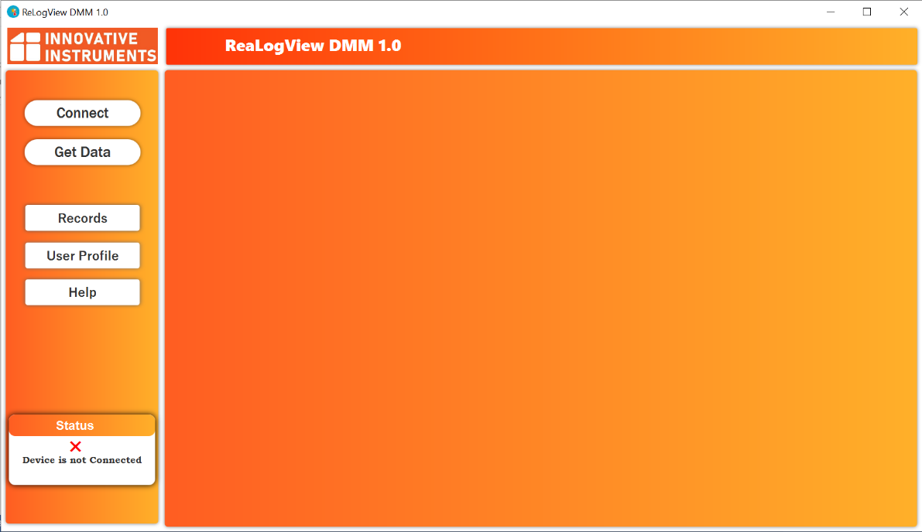

1. **Status window:**

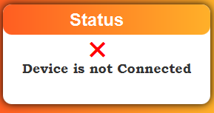

The Purpose of Status window is:-

* To check that device is connected or not connected.
* To track Email sending Progress.

1. **Device Port Connection:**

On click “Connect” Button the following window will show.

Port selection process gone through this window. Device will connect by selecting the port.

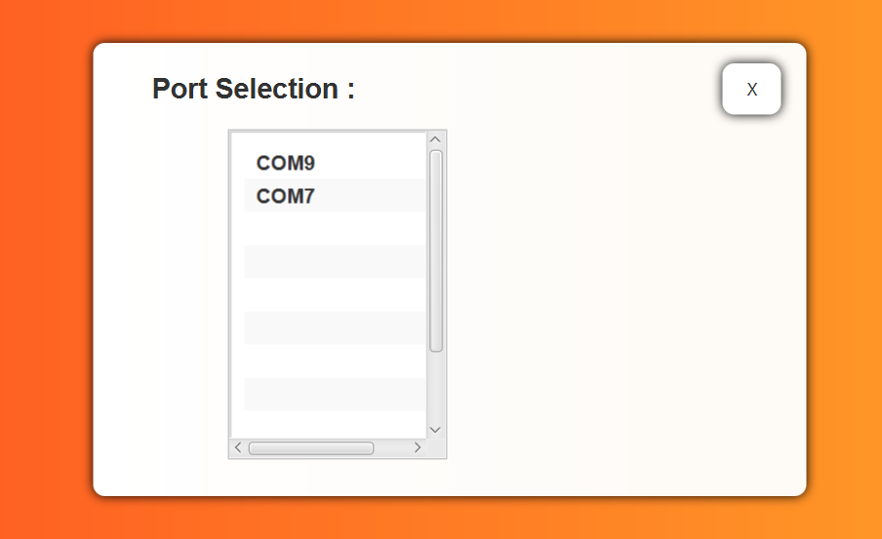

Select device port to Connect.

1. **Get Measured Data From Meter:**

To receive and Display measured data From Meter click on “**Get Data**” Button.

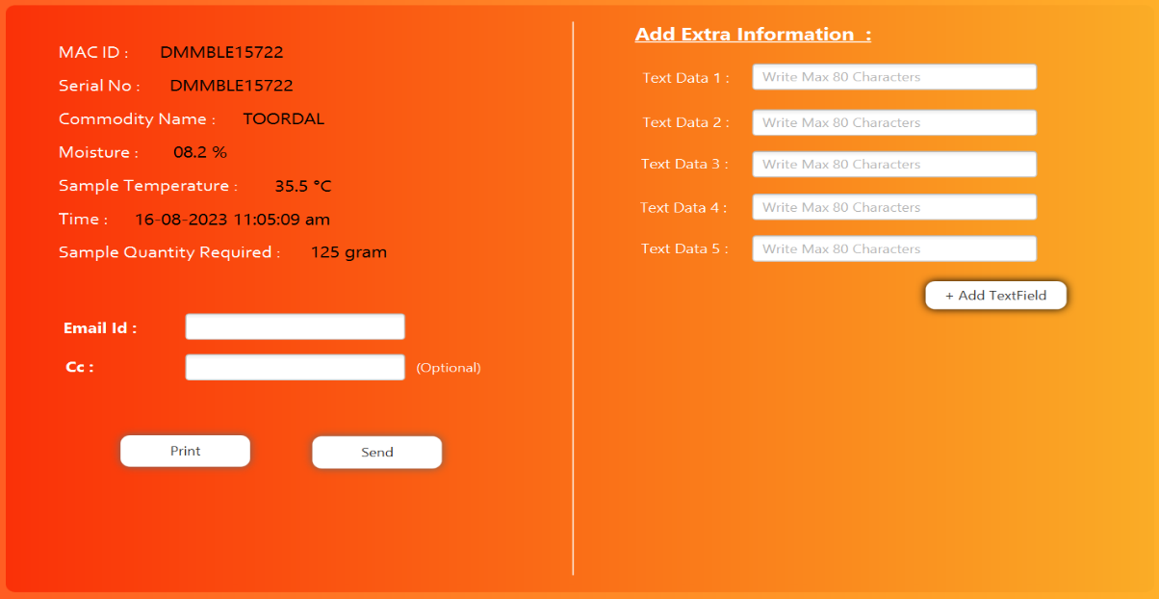

User can add Extra Information in text fields, as show on right side section.

“Print” To print received data and generate pdf at C:\Users\{UserName}\Realogview\DMM1.0\Data\PDF.

“Send” To share received data as Pdf Format, after fill up Email Address.

1. **View Recorded Data:**

On click “Records” Button, the below window will appear.

The main purpose of this window is to perform operation on past recorded data.

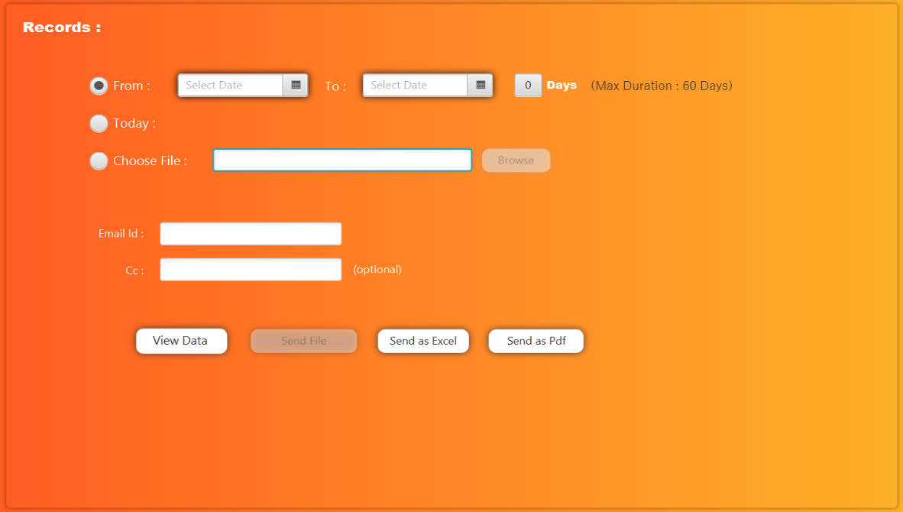

* **NOTE**: The Maximum duration is 60 days for Dates selection.
* **Option 1:**



Select first option to get recorded data, between two particular dates.

* **Option 2:**



Select second option to get today’s all recorded data.

* **Option 3:**



Select third option to choose file.

After selection any option, user can share and view recorded data or selected file.

“Send as Excel” is to send recorded data as excel format.

“Send as Pdf” is to send recorded data as pdf format.

“Send file” is to send Browsed file.

“View Data” is to show Recorded data as table format or view browsed file, [Table Show as below].

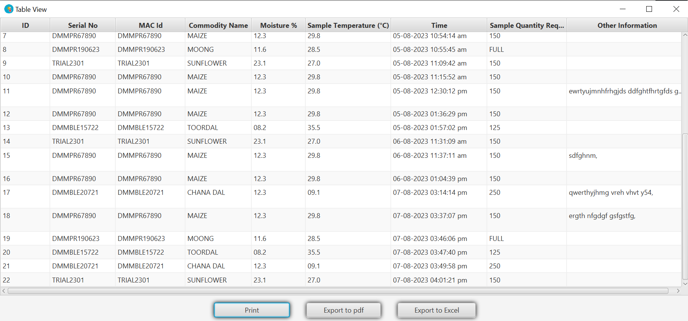

Click on “**print**” to Print Table.

Click on “**Export as pdf**” to export table as pdf.

The pdf store at C:\Users\{UseName}\Realogview\DMM1.0\Records\PDF

Click on “**Export as excel**” to export table as excel.

The excel store at C:\Users\{UseName}\Realogview\DMM1.0\Records\PDF

**Setup User Profile:**

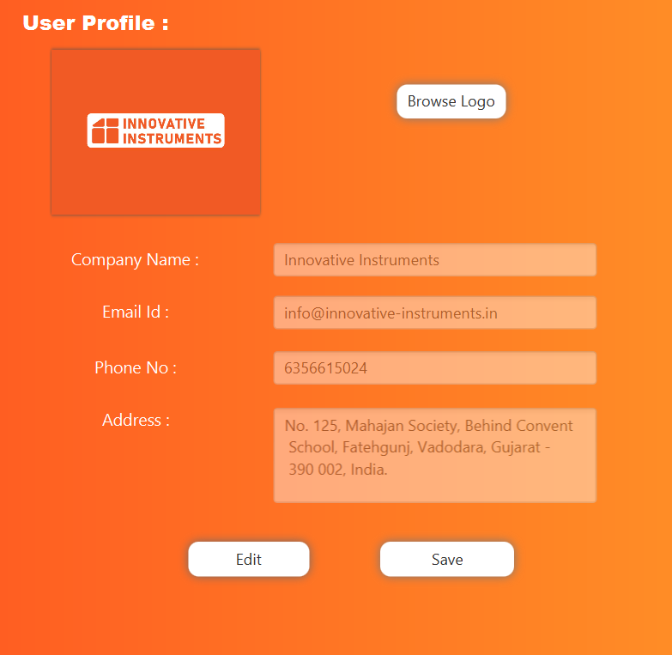

* **Note: default information fill up of Innovative Instrument Company.**

User can set up their company profile details (like name, address, email, phone no and logo), as show above.

**The end**

-------------------------------------------------------------------------------------------------------------------------------------------------------